# Final Design

Our final design as shown below in Figure 1, intends on reducing the damage caused by water, mold, and hazardous gases by giving homeowners and other property owners a variety of useful data instantly without a large upfront cost. The use of this data will warn property owners of potentially harmful indoor conditions and allow mitigation techniques to be implement before damage occurs. Further, the final design utilizes three main portions of engineering to achieve a fully functional home monitoring system.

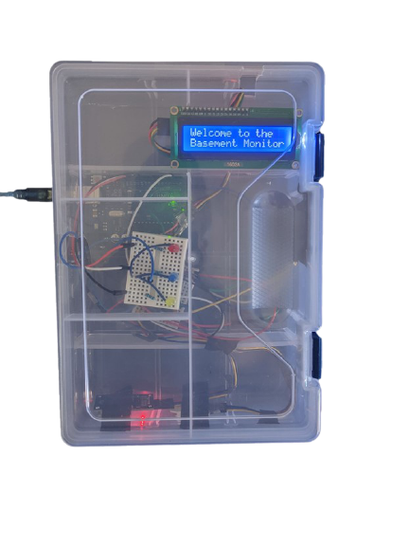 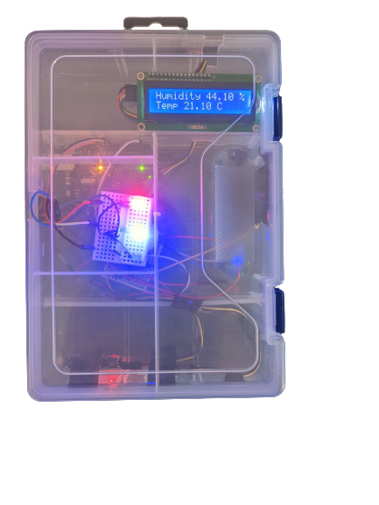

Figure . The Basement Extraordinaire Final Design. This image displays the welcome text on the LCD monitor and an image of the product taking temperature and humidity readings.

## Electrical Design

The electrical design was the most significant design factor of this project. Further, the product is reliant on the use of two electrical sensors, the DHT22 Humidity and Temperature Sensor and the MQ-135 Hazardous Gas Sensor to gather read and write the environmental data to the Arduino. The DHT22 is a low-cost capacitive humidity sensor and an environmental thermistor [1]. As seen in Figure 2, capacitive humidity sensors are composed of an air-filled capacitor that changes permittivity depending on the moisture in the atmosphere [2].  Permittivity is a material’s capability to polarise in response to an applied field. In this case, the applied field is the electric field produced by two parallel charged layers. The main advantages of capacitive humidity sensors are the linear output voltage which supplies stable results over prolonged usage, and the ability to detect a wide range of humidity values [2].

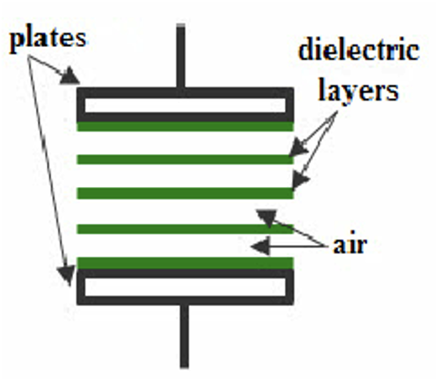

Figure 2: Capacitive humidity sensor electrical diagram. Plates are featured in black, with dielectric layers between the plates in green [3].

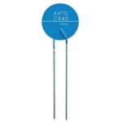According to United States Environmental Protection Agency (EPA), Indoor relative humidity should be kept between 30 and 50 percent [4] [5], so it is important that the humidity data collected by the DHT22 sensor have a warning threshold set between 30 to 50 percent humidity. Next the thermistor change resistance based on the apparent surrounding temperature. As seen in Figure 3, a thermistor is made from a metallic oxide material which is compressed into a bead on the end of two wires and coated in glass or sometime of epoxy. The DHT22 sensor uses a Negative Temperature Coefficient thermistor or NTC, which resistance decreases as the surrounding temperature increases, the voltage drop across the resistor is then inversely proportional to the temperature [6].

Figure . A Negative Temperature Coefficient Thermistor similar to the one used within the DHT22 Temperature and Humidity sensor.

The DHT22 converts both the capacitive humidity data and resistive temperature data from a range of 0 to 100% humidity with an accuracy of 2 to 5% and from -40 to 80 oC with ±0.5 oC uncertainty [1]. This sensor is optimal for measuring indoor conditions since it covers the range of possible temperatures and humidity as well as reacting to small changes in the environmental conditions. The output of the DHT22 is split on the data pin and this sensor requires no analog data [1]. As seen in Figure 5, to regulate the input voltage a 10 k Ohm resistor was attached to the Data pin (2nd pin in forward facing orientation), the VCC pin was attached to the 5V output from the Arduino, the Ground pin was attached to the ground pin on the Arduino and the Data was sent to the 2nd Digital pin on the Arduino.

Next, the MQ-135 Hazardous Gas sensor as shown below in Figure 4, was chosen since it can detect several gases including ammonia, nitrogen, oxides, alcohols, aromatic compounds such as benzene, methane, propane, sulfide gases and smoke, and convert these pollutants into a general air quality measure in PPM [7]. The internal resistance of the MQ-135 is inversely proportional to the air quality, having a higher internal resistance in clean air through the use of a Tin(IV) oxide resistor [7]. The voltage drop across the resistor is then converted to an air quality measurement in PPM and sent to the Arduino. The sensor has both a Digital and Analog out pin for transferring the data to the Arduino.

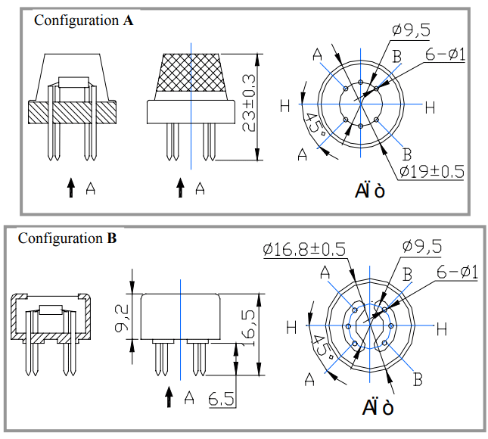

Figure . The MQ-135 working drawing including a section view and component measurements with respective tolerances [7].

As shown in Figure 5, the VCC pin was attached to the output voltage and the Ground pin was attached to the ground pin on the Arduino while the Analog Out pin was attached to the 3rd Analog In pin on the Arduino.

As well, an LCD 16x2 I2C display was added to the circuit to display the sensor readings live. The addition of the screen was an important part of the system since it allows the end user to quickly read the data and get warnings for dangerous conditions. The screen also allows the product to display the readings without being connected to a computer. To allow the brightness of the screen to be adjusted to best match the home environment a rotary potentiometer was attached to the LCD screen.

Lastly an Adafruit SD shield was added on top of the Arduino so that the sensor data could be written onto an SD card and stored on the device for future evaluation.

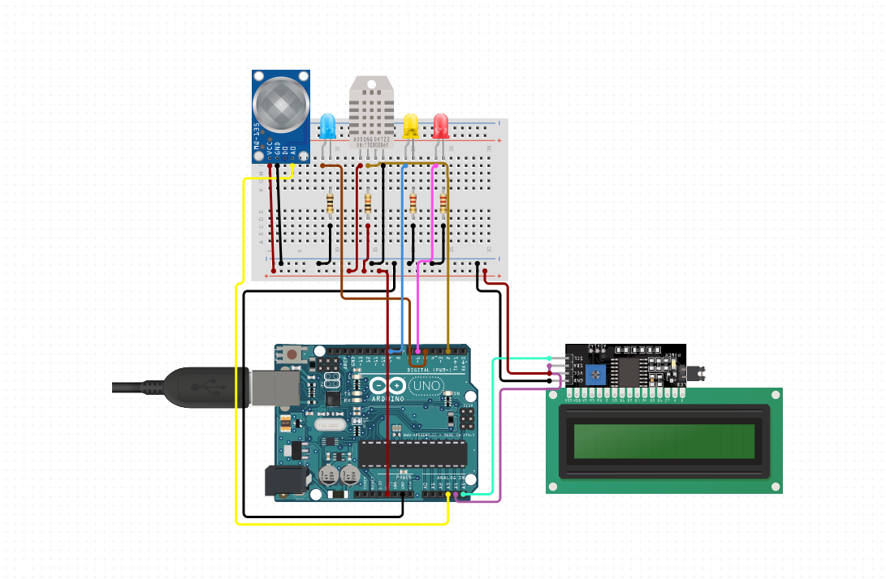

Figure . Electrical design diagram for the final design of the product including the MQ-135 gas sensor, DHT22 temperature and humidity sensor, LED threshold lights and an LCD monitor [8].

## Mechanical and Physical Design

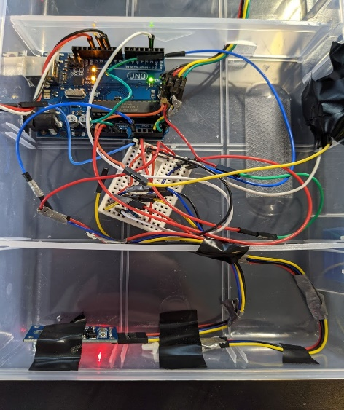A large portion of the final iteration of the prototype involved creating an internal and external casing that allowed the electrical components to be correctly placed and allow for an ease of implementation and use. One critical design factor was creating a case with separate sections for the internal and external facing components. Further as shown in Figure 6, the final case design included several sections to hold the electrical components in place and to ensure that the components are shock resistant.

Figure . Image of the interior of the final design, including the Arduino and the main breadboard used to configure the electrical components.

As well, it was important to select a transparent casing so that the LED’s and LCD screen could be viewed without sacrificing the waterproofing of the case. Additionally, as seen in Figures 7 and 8, holes needed to be cut into the different sections of the case to ensure the several wires could attach to the various components and so that the sensors, charging inputs and buttons could be accessible from outside the case.

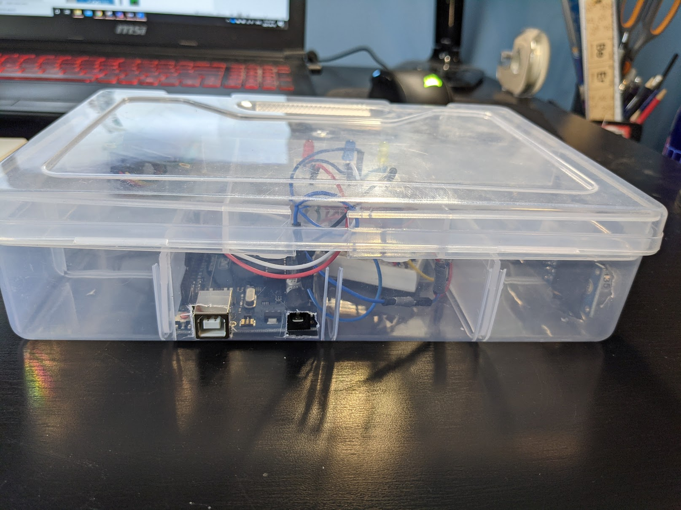 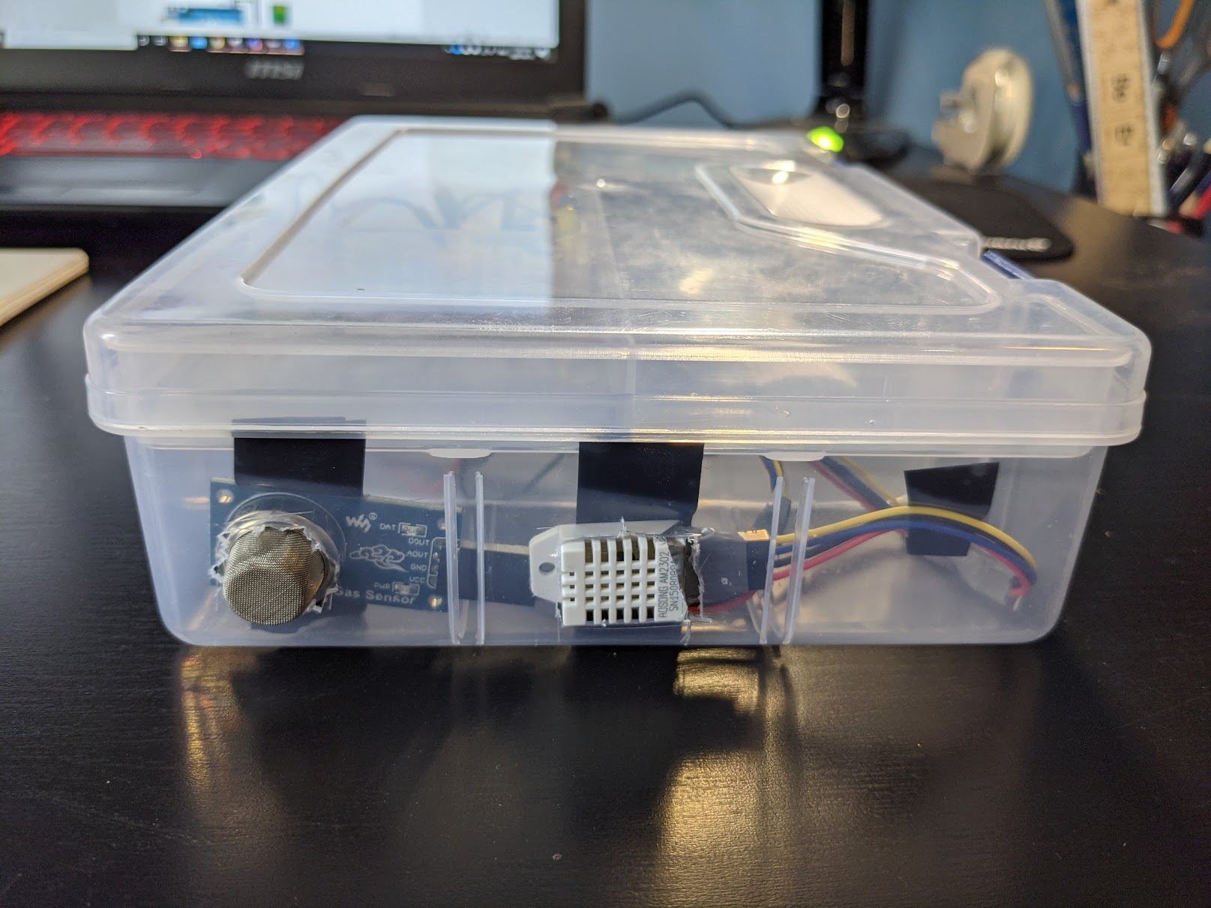

Figure . Picture of the prototypes exterior casing and the holes cut out for the charging inputs and well as the sensors mounted on the side and bottom of the case, respectively.

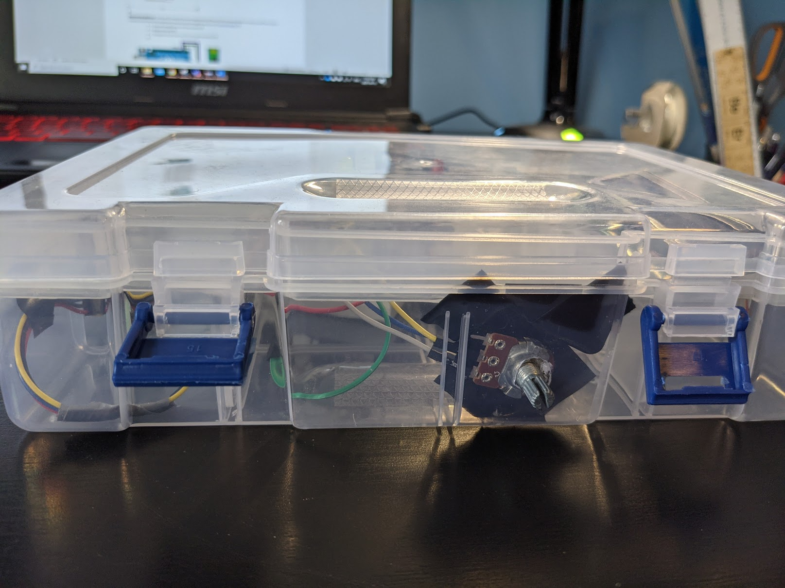

Figure . Picture of the exterior of the final prototype with potentiometer attached to the side of the case along with the latches.

It was also important to have easy accesses to the inside of the case to quickly fix any problems, so as seen in Figure 8 instead of using a screw-on top, the team decided to use a case with latches allowing the top to come off easily. Additionally, as seen in Figure 9 the top layer of the prototype includes a breadboard with the warning LED’s and the LCD screen. 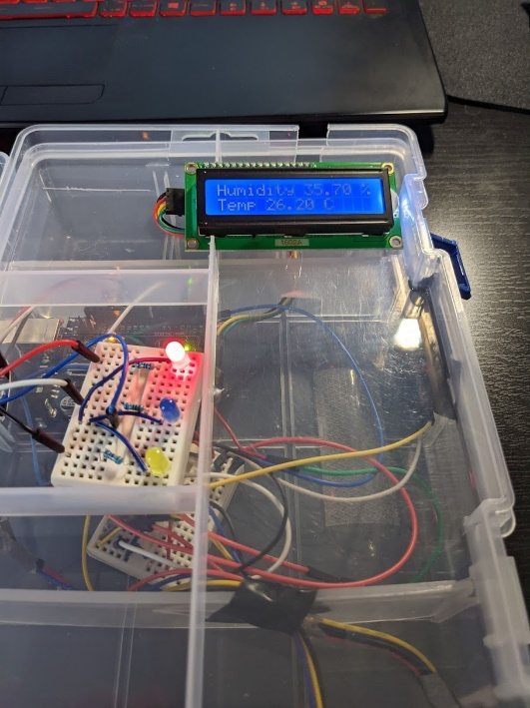

Figure 9. Top layer of the interior casing with the 16 by 2 LCD monitor and the three LEDs for threshold warnings.

These components were placed on their own layer so the customer could easily view the output without the visual noise of the rest of the circuit.

## Programming and Software Design

Although programming may seem like the simplest part of the final design, the team tried to utilize the full potential of the prototype and created several different programs using three different languages (MATLAB, Arduino C and Python) to create a variety of modes and outputs. Further the team developed two versions of the main Arduino code one to be run from a computer (Online Version) that utilizes the serial monitor to let the user decide what sensor data to take in and read to the LCD screen, and serial monitor and a version in which the device can just be plugged into a wall outlet (Offline Version) and output the readings onto the LCD screen and SD card. Further the online version was created to quickly get only a specific sensor reading and then easily transfer the data to MATLAB or Python and produce live graphs of the data as seen below in Figures 10-12, to develop calibration techniques and test calibration algorithms.

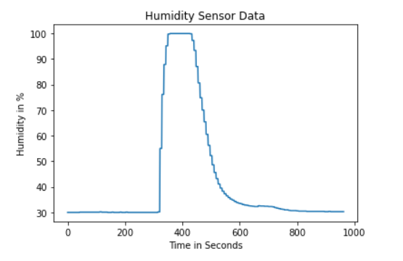

Figure . DHT22 Humidity data when exposed to a moist breath.

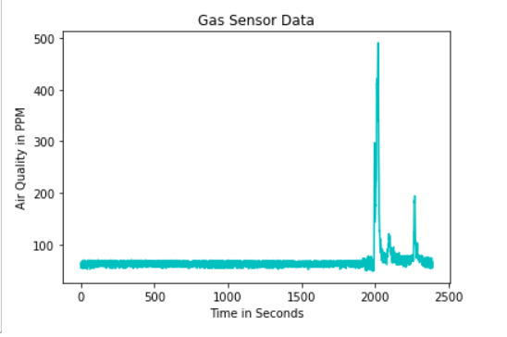

Figure . MQ-135 hazardous gas readings including peaks when exposed to propane and butane lighters.

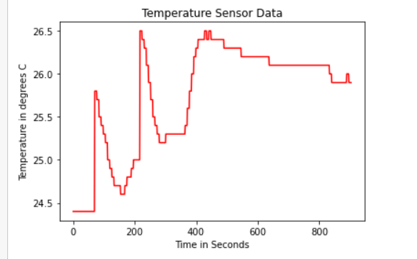

Figure . DHT22 Temperature data in degrees Celsius when exposed to the skin temperature of a finger.

In each of the plots displayed about the sensors were exposed to an extraneous circumstance causing the readings to increase or decrease drastically, such as the humidity from a breath, an exposure to butane gas and subject to skin temperature. As well in the Online mode line plots are available through the use of the serial plotter as shown in Figure 13.

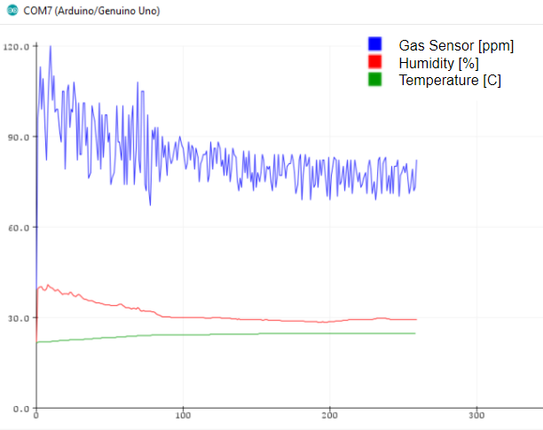

Figure . The serial plotter for the live data produced by the product in the online mode.

The Arduino code for the DHT22 temperature and humidity monitor uses an adjusted moving average algorithm that takes the most recent 10,000 temperature and humidity readings and sets a threshold based on the average of the data. However, built into this algorithm is also static thresholds for instances where the house is initially subject to high temperature or humidity.

# Recommendations and Future Design

Although the team achieve most of the goals set out during the early stage of the design process there are still many factors of the product that can be improved or iterated upon. Many of the improvements for the product have to do with the addition of a Bluetooth shield, as shown in Figure 14. Further, the addition of a Bluetooth shield will allow the team to connect the prototype remotely to any computers and cellphones with Bluetooth capabilities.

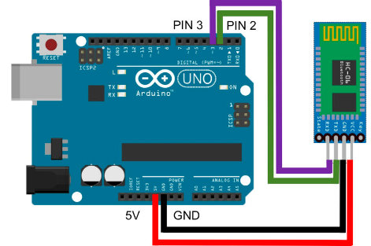

Figure . Example electrical diagram for an Arduino connected to a Bluetooth shield.

As well, the addition of a Bluetooth/Wi-Fi shield will allow the team to keep track of where each unit is placed and create networks of the devices data. The live data from specific areas will allow the device to integrate into the governments preexisting data bases and help government entities best respond to natural disasters and other mitigation projects. As well, the use of local and global databases to further develop the moving thresholds to best meet a specific environment will allow the product to be more accurate than any other home monitors on the market. Currently existing waring measures like Amber Alerts could be paired with the Basement Monitor and allow the government to send geographically specific warnings to certain households during flooding and other natural disasters. As well, through the Bluetooth and Wi-Fi connection the Basement Monitor will include a smart home app and allow homeowners to track the sensor data in real time as shown in Figure 15.

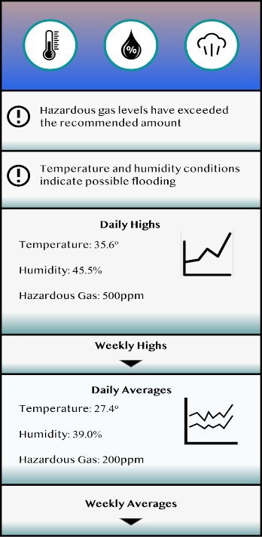

Figure 15. Wireframe design of the mobile application for the future of the Basement Monitor.

The addition of a mobile and web application would allow another opportunity to warn homeowners of potentially dangerous conditions in their household and would not require them to watch the device. Moving to a more software-based product allows updates and design iterations to be more quickly implemented and takes the cost of each iteration down drastically [9]. As well once the data is held within a network the team could develop the device to allow integration into preexisting smart home devices like Amazon Alexa or a Google Home. By integrating into those systems, the home monitor expands its capabilities drastically. For example, our product could be integrating into a smart home and run a sump pump every time a humidity level reaches a certain threshold to ensure flooding damage does not occur or is mitigated. As well, if carbon-monoxide gas is detected a message could be played through the smart home device and tell all occupants to exit the building immediately. These future additions open the technology up to a much larger demographic of customers including hotels, apartment buildings and resorts, since they all have economic benefits to upgrading their safety equipment.